DS 522 Data Acquisition and Analytics
HOS03A-2 – NumPy Basics
07/15/2024 Developed by Catherine Ata
04/15/2025 Reviewed by Naveena Moddu
02/13/2026 Revised by Jonathan Koerber
03/31/2026 Reviewed by Vishal Krishna Kumar

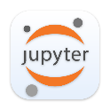


School of Technology & Computing (STC) @ City University of Seattle (CityU)

Take Note Before Starting
• The directory path shown in screenshots may be different from your directory.
• Not every step is explained in the tutorial. If you are not sure what to do:
1. Consult the resources listed below.
2. If you cannot solve the problem after a few tries, email your course TA for help.

Learning Outcomes
• Understand IPython - environment.
• Learn how to install Jupyter extension on Visual Studio Code.
• Learn how to run programs in Jupyter notebook.

Resources
- McKinney. (2022). Python for Data Analysis (3rd edition).
- Tutorials Point. (2024). Python Tutorial. NumPy Tutorial

Getting Started
- Open the VS code and within the VS Code, open the DS522 course folder created earlier. On the menu tab, select File, then Open New Folder. Navigate to your work directory or GitHub repository that you have cloned.
For example: C:\Users\my_workspace\Desktop\DS522
The "Socratic Tutor" Philosophy
A Socratic tutor doesn't give you the answer; they ask the right questions to help you find the answer yourself. When using AI, your goal is to understand the logic, not just the output.
Guide for best results:
- Explain, Don't Replace: Use AI to explain error messages or logic. Never copy-paste code without being able to explain what every line does.
- The 10-Minute Rule: If you are stuck on a "creative judgment" problem for more than 10 minutes, describe your problem to the AI and ask for a "hint" rather than the full solution.
- Verify the Output: AI can sometimes "hallucinate" (make mistakes). Always compare the AI’s explanation with the actual results you see.
- Cite Your Assistant: If an AI helps you solve a particularly difficult bug, add a comment in your code like: # Logic assisted by AI to resolve non-numeric error
In addition to submitting the code you write following this exercise leverage to help in your learning by answering challenge questions given throughout the assignment.

OR C:\Users\my_workspace\Desktop\DS522\github_repository_name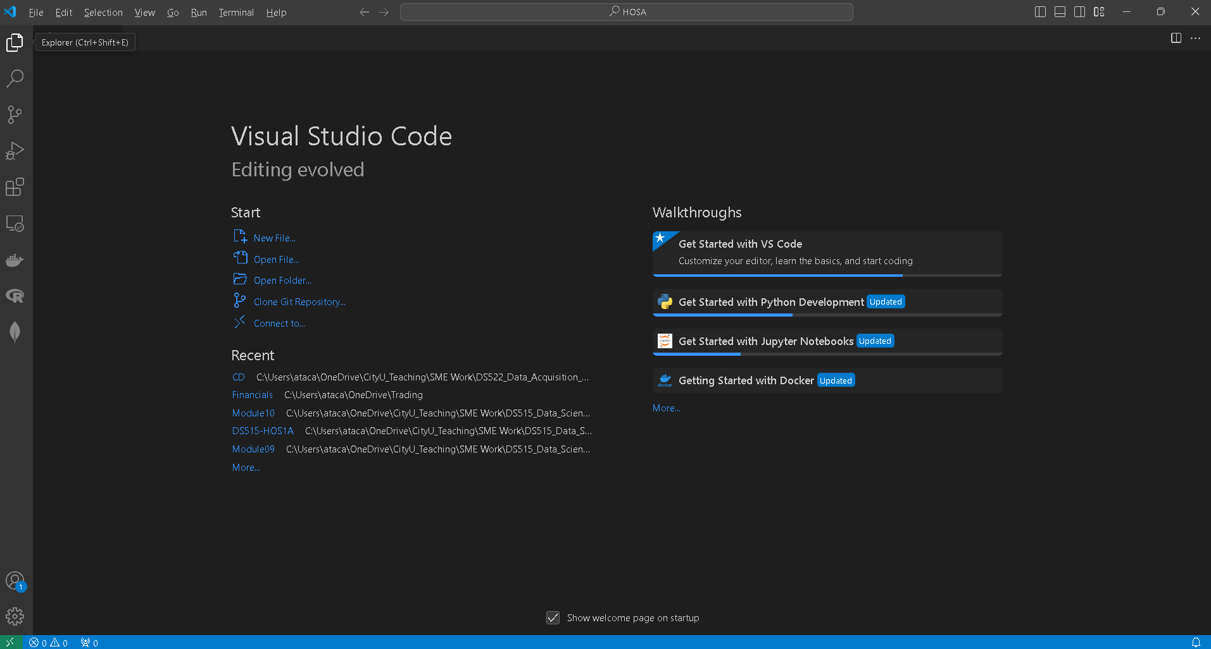
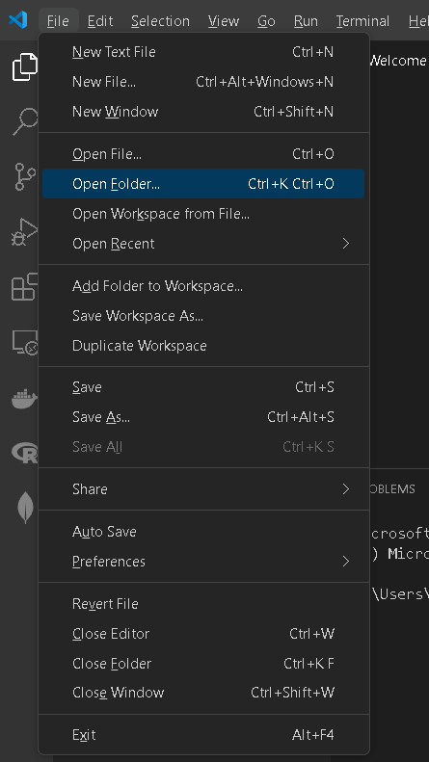
NOTE: If you have cloned a GitHub repository that is provided specifically for this course, navigate to that directory and skip steps 2 to 4. This will be the folder where you will be storing all your HOS03A work.
- Once in your work directory, go to the menu tab again, select Terminal, select New Terminal to open a Command Line Interface (CLI) like the Command Prompt or PowerShell for Windows OS.
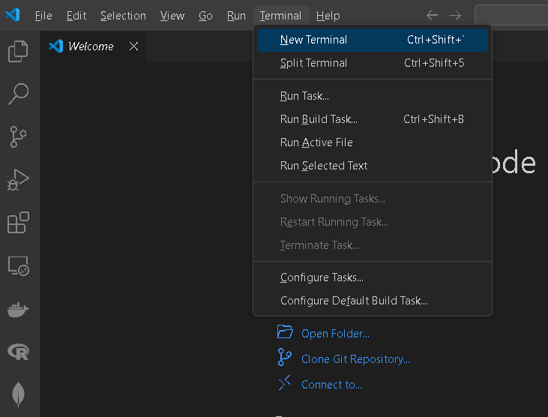

- Inside your “DS522” directory, create a new directory and name it “HOS03A”. Use the following command:
>mkdir HOS03A
- Move to the new directory. Use the following command:
>cd HOS03A
NOTE: This will be the folder where you will be storing all your HOS03A work.

NumPy

What is NumPy?
NumPy (Numerical Python) is a fundamental package for scientific computing in Python. It provides support for large multidimensional arrays and matrices, along with a collection of mathematical functions to operate on these arrays efficiently.

Integration with Other Libraries
- NumPy integrates seamlessly with other scientific libraries like SciPy, Pandas, and Matplotlib, making it a cornerstone of the Python scientific computing ecosystem.

Performance
- NumPy is highly optimized for performance. Operations on NumPy arrays are much faster than the equivalent operation on Python lists due to its efficient memory handling and the use of vectorized operations.

Applications
NumPy is used extensively in areas such as:
- Data analysis and manipulation
- Machine learning
- Simulation and modeling
- Image and signal processing
- Financial analysis

NumPy is essential for anyone working with data in Python, providing the tools needed for efficient computation and manipulation of numerical data.

In this exercise, we will cover some key features and functionalities of NumPy.

Installing NumPy

1. Run the command in a terminal:
>>>pip install numpy

A. Ndarray (N-dimensional Array Object)
- Core of NumPy: The ndarray is a powerful N-dimensional array object that provides fast and efficient operations on homogeneous data (items of the same type).
- Properties:
  - Shape: The dimensions of the array (e.g., a 3x4 array).
  - Dtype: The data type of the array elements (e.g., int32, float64).
  - Size: The total number of elements in the array.
  - Itemsize: The size (in bytes) of each element in the array.

A dtype is described in the following aspects:
• Type of the data (integer, float, Python object, etc.)
• Size of the data (how many bytes the data is, e.g., the integer)
• Byte order of the data (little-endian or big-endian)
• Structured data type (e.g., describing an array item consisting of an integer and a float)

1.Under the HOS03A folder or HOS3A repository, create a file named “data_types.ipynb” and type the following code:
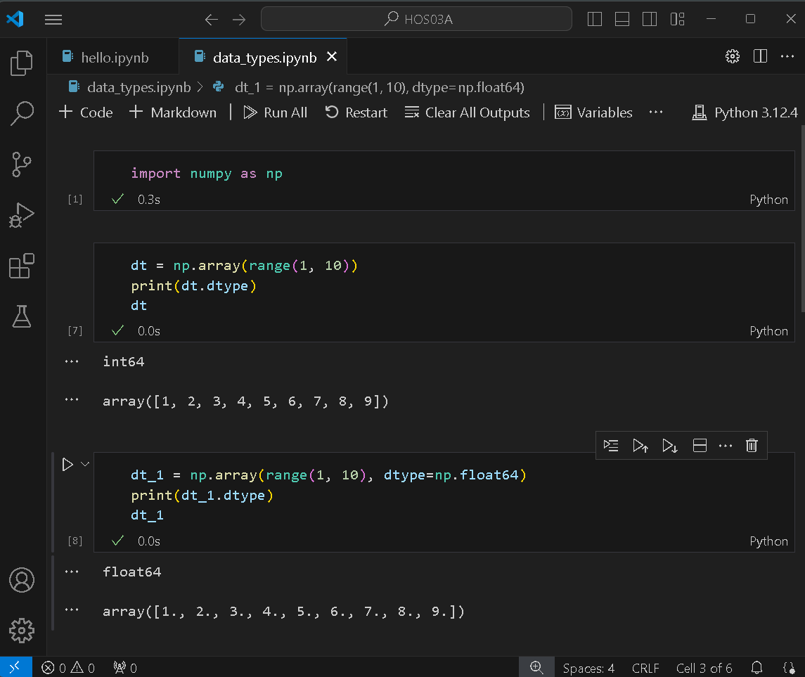
2. Add a new code cell to your notebook by clicking the +Code button on the top menu bar, as seen in the image below.
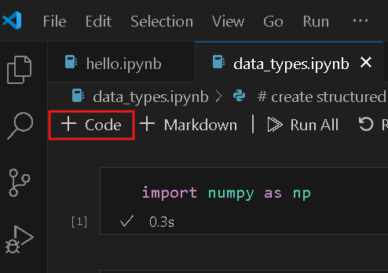

Add the following code to “data_types.ipynb”.
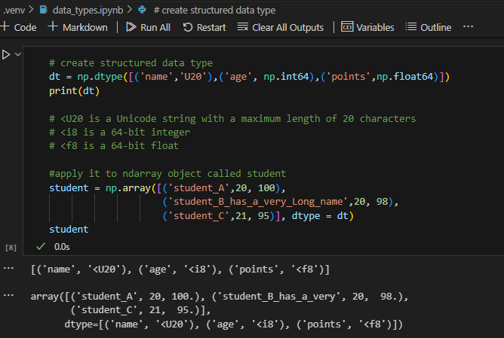

3. Let’s try another example, type the following code to a new cell in your notebook, then run the code cell.

Type this line of code to a new code cell to access the values of a column:
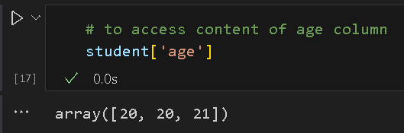
- TO DO: Add another code cell, then access the values of the other columns. Put your code in a separate code cell for each column value.

Challenge: What are the primary use cases for multi-dimensional arrays, and why does NumPy’s contiguous memory allocation outperform Python's nested lists?"

Multi-dimensional arrays are mainly used in scientific computing, machine learning, image processing, and data analysis because they efficiently represent structured numerical data like matrices, tensors, and pixel grids. NumPy outperforms Python’s nested lists because it stores data in contiguous memory blocks with a fixed data type, which improves CPU cache efficiency and eliminates pointer overhead; combined with vectorized operations executed in optimized C code, this allows NumPy to perform computations much faster than Python loops over lists.

B. Array Creation
- Arrays can be created from Python lists or tuples using the np.array function.
- NumPy provides functions for generating arrays with specific conditions:
  - np.zeros(shape): Creates an array filled with zeros.
  - np.ones(shape): Creates an array filled with ones.
  - np.arange(start, stop, step): Creates an array with values from start to stop (exclusive) with a specified step.
  - np.linspace(start, stop, num): Generates an array with num evenly spaced values between start and stop.

1.Under the HOS03A folder or HOS3A repository, create a file named “arrays.ipynb” and type the following code. Run each code cell by clicking on the run button in the upper left side of each cell.
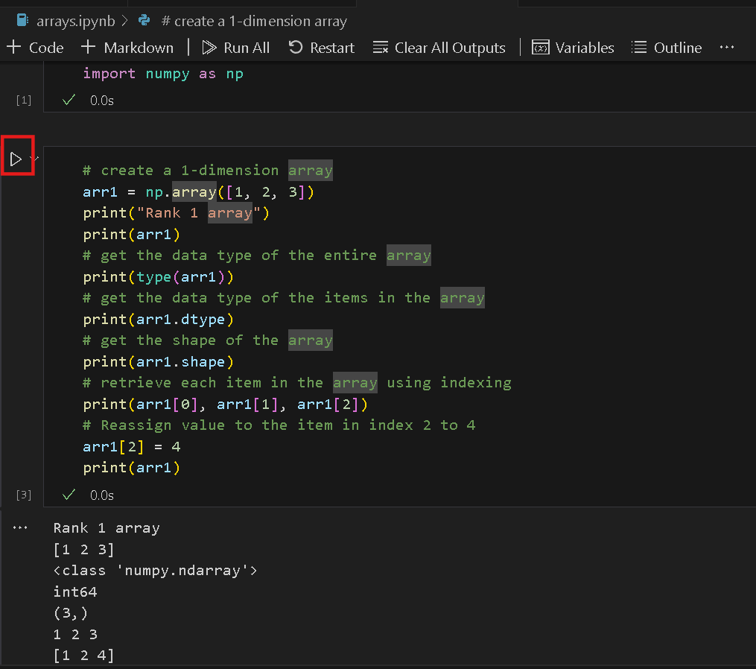

2. In the previous cell, we created a 1-dimensional array; this time let us create a 2-dimensional array. Add a new code cell then add the lines of code below. Again, run the code and output.
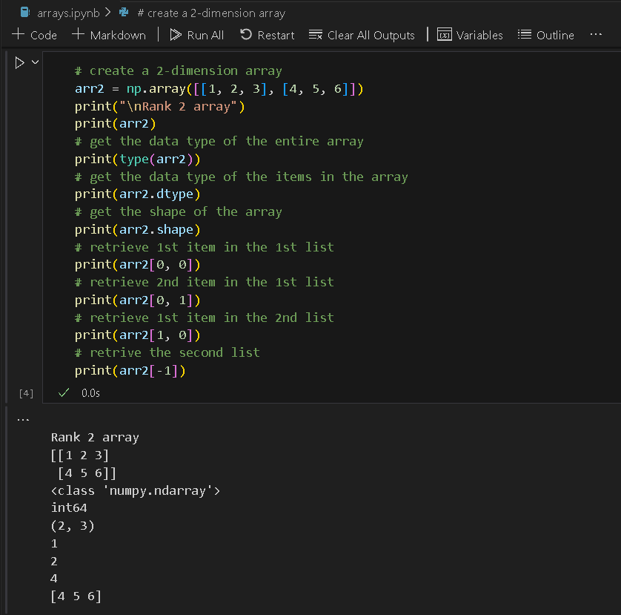

3. Now, let us create a nested array using the ndmin key to pass the np.array function when creating an array from a range of numbers from 0 to 5. Type the code in a new cell, then run:
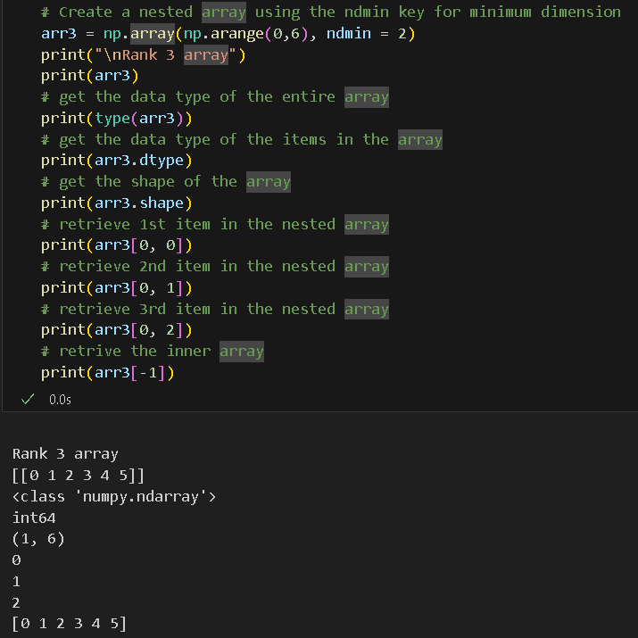

4. Add the following code to a new cell to generate different arrays using NumPy functions.
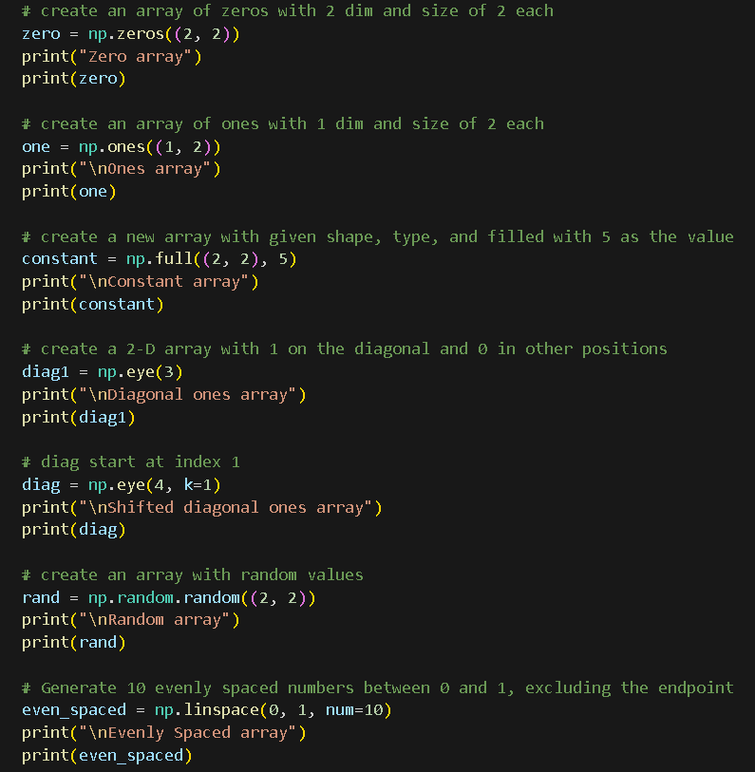
Run the code cell to see the output.
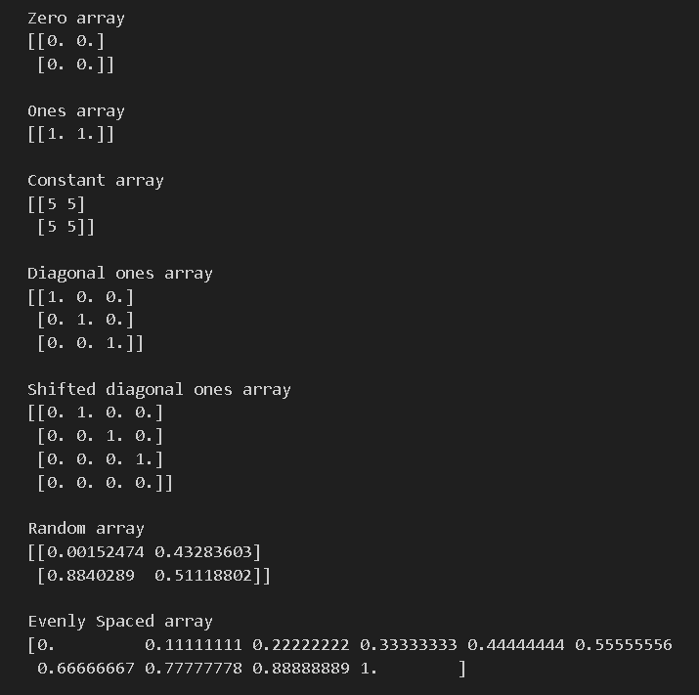
C. Array Manipulation
Reshaping and Resizing
- Reshape: np.reshape allows you to change the shape of an array without changing its data.
- Resize: np.resize changes the shape and the size of the array, possibly repeating the data.

- Add a new code cell in your “arrays.ipynb” notebook and type the following code. Run each code cell by clicking on the run button on the upper left side of each cell.

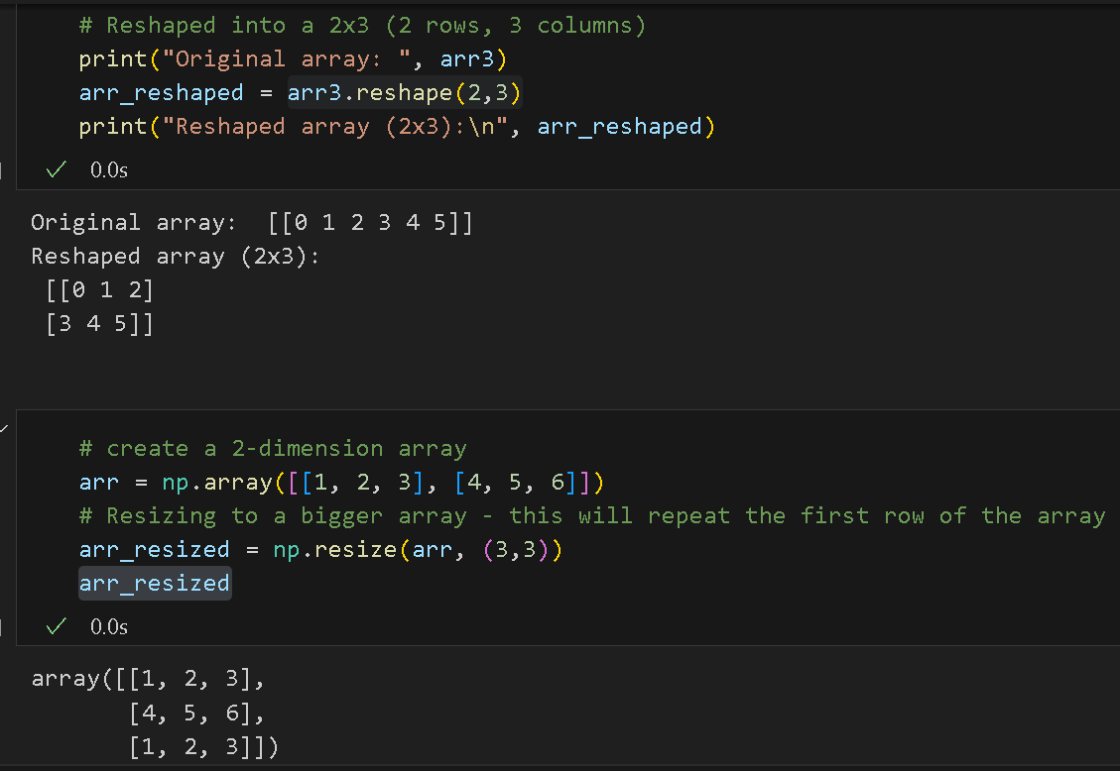

Flattening:
- Flatten: flatten () method returns a new 1D array containing all the elements of the original array in a single row (flat). It doesn't modify the original array but instead creates a copy.
- Flat: flat is an iterator that lets you traverse and modify the original array elements as if they were in a 1D array, without creating a new array.

- Add a new code cell in your arrays.ipynb notebook and type the following code. Run each code cell by clicking on the run button in the upper left side of each cell.
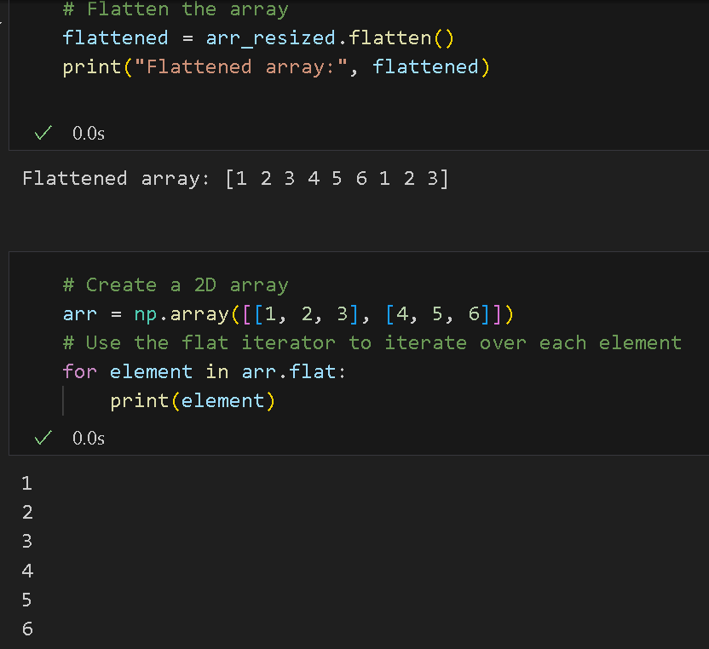
Challenge: What are the primary risks to data integrity when flattening a NumPy array? Specifically, explain the difference between a 'view' and a 'copy', and how using. ravel() VS .flatten() method can lead to accidental data mutation or memory errors.

Flattening a NumPy array introduces risks mainly around unintended data mutation and memory semantics. The key distinction is between a view and a copy: a view shares the same underlying memory as the original array, so modifying it also modifies the source, while a copy allocates new memory, making it independent. The method .ravel() returns a view whenever possible (only creating a copy if required by memory layout), making it memory-efficient but risky changes to the flattened array can silently alter the original data, leading to integrity issues. In contrast, .flatten() always returns a copy, ensuring safety from accidental mutation but using more memory. Therefore, using .ravel() in pipelines or transformations can introduce subtle bugs if you assume independence, whereas .flatten() trades performance for data isolation and reliability.

Transposing:
- Transpose: T attribute is used to transpose an array, which means swapping its rows and columns.
- Add a new code cell in your “arrays.ipynb” notebook and type the following code. Run the code cell by clicking on the run button in the upper left side of each cell.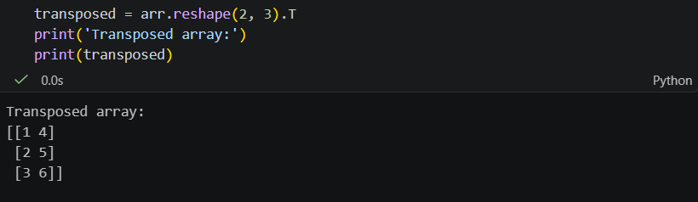

Concatenation and Stacking:
- Concatenate: np.concatenate is a general-purpose function for joining arrays along an existing axis.
- Stack: np.vstack is specifically designed to stack arrays vertically, meaning it always stacks along the first axis (axis=0).
- Add a new code cell in your “arrays.ipynb” notebook and type the following code. Run each code cell by clicking on the run button in the upper left side of each cell.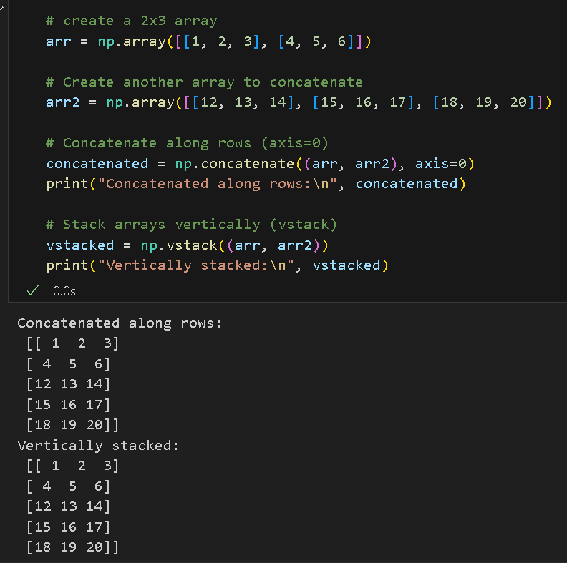

Challenge: What is the difference between concatenating two arrays and vertical stacking two arrays. In the above example, they return the same result. What cases would these not return the same result?

Concatenation (np.concatenate) is a general-purpose operation that joins arrays along any specified axis, while vertical stacking (np.vstack) is a specialized convenience function that always stacks arrays row-wise (along axis 0) and will first reshape 1D arrays into 2D row vectors if needed.

Finding Unique Elements
- Unique: np.unique() function in NumPy is used to find the unique elements of an array. It also has options to return additional information such as the indices of the unique values and their counts.
- Add a new code cell in your “arrays.ipynb” notebook and type the following code. Run the code cell by clicking on the run button in the upper left side of the cell.
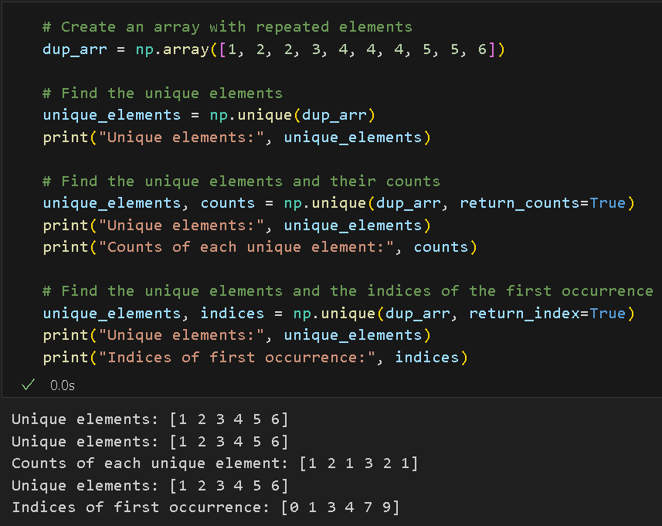

Indexing and Slicing
- Basic Indexing: Like Python lists, but with support for multi-dimensional arrays.
- Add a new code cell in your “arrays.ipynb” notebook and type the following code. Run the code cell by clicking on the run button in the upper left side of the cell.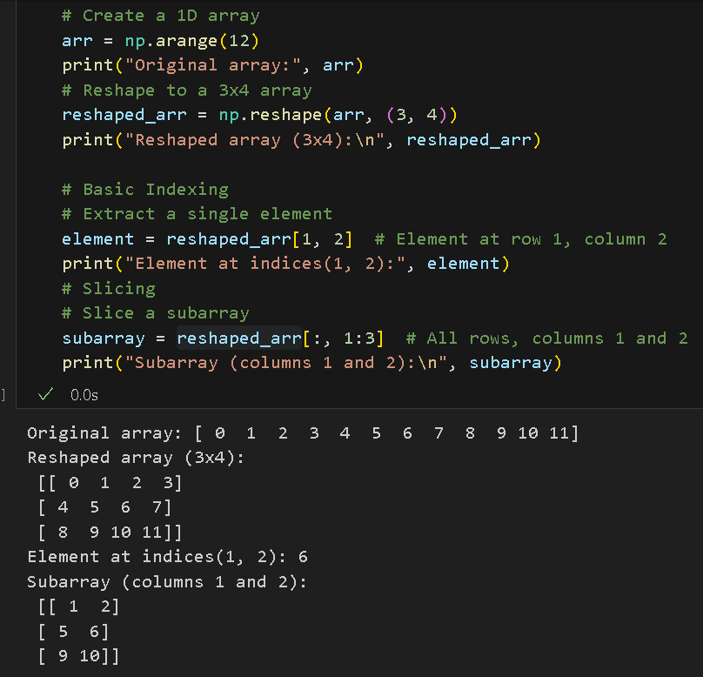
- Fancy Indexing: You can access multiple elements of an array using arrays of indices.
- Boolean Indexing: Allows filtering of array elements using conditions.

- Add a new code cell in your “arrays.ipynb” notebook and type the following code. Run the code cell by clicking on the run button in the upper left side of the cell.
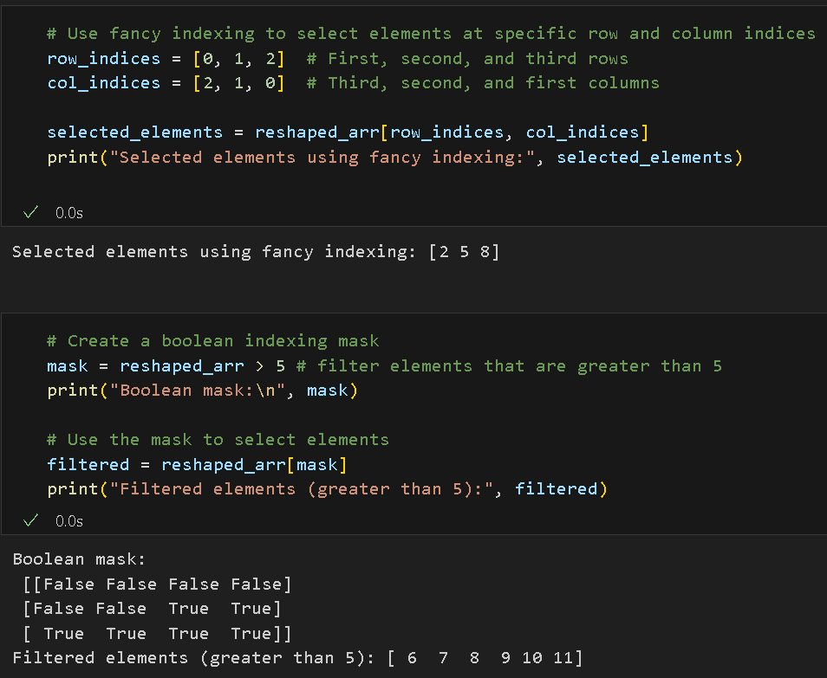

D. Array Operations

- Element-wise Operations: You can perform arithmetic operations (addition, subtraction, multiplication, etc.) element wise.
- Add a new code cell in your “arrays.ipynb” notebook and type the following code. Run the code cell by clicking on the run button in the upper left side of the cell.

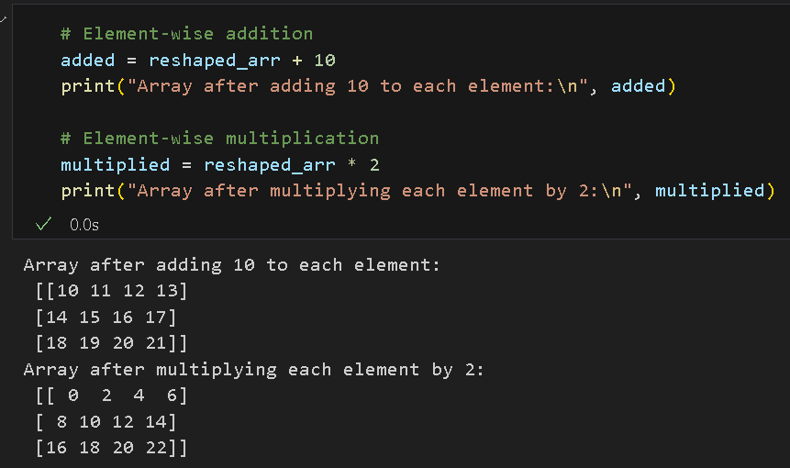

- Matrix Operations: Matrix multiplication, transposition, and other linear algebra operations are easily handled using functions like np.dot () and np.matmul().

- Add new code cells to your “arrays.ipynb” notebook and type the following code. Run the code cells by clicking on the run button in the upper left side of the cells.

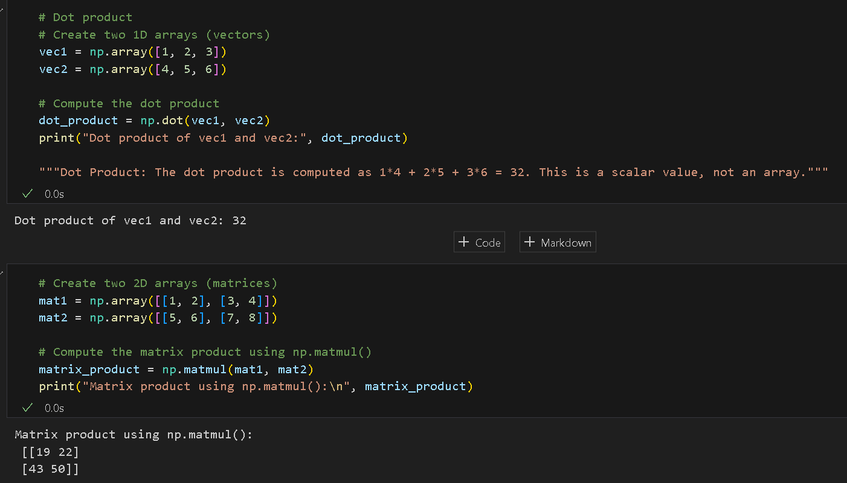

Challenge: Apply dot product operation to mat1 and mat2. Compare results to np.matmul.
Write the code and explain why it works in the challenge document.

For 2D arrays, np.dot() and np.matmul() perform the same operation: matrix multiplication. This works because both functions follow the linear algebra rule of multiplying rows of the first matrix by columns of the second matrix and summing the results. The outputs are identical because both functions interpret 2D inputs as matrices. The difference only appears in higher dimensions (3D+), where matmul supports broadcasting while dot has different summation behavior.

- Broadcasting: NumPy allows operations on arrays of different shapes in a way that avoids making unnecessary copies of data.

3. Add a new code cell in your “arrays.ipynb” notebook and type the following code. Run the code cells by clicking on the run button on the upper left side of the cells.

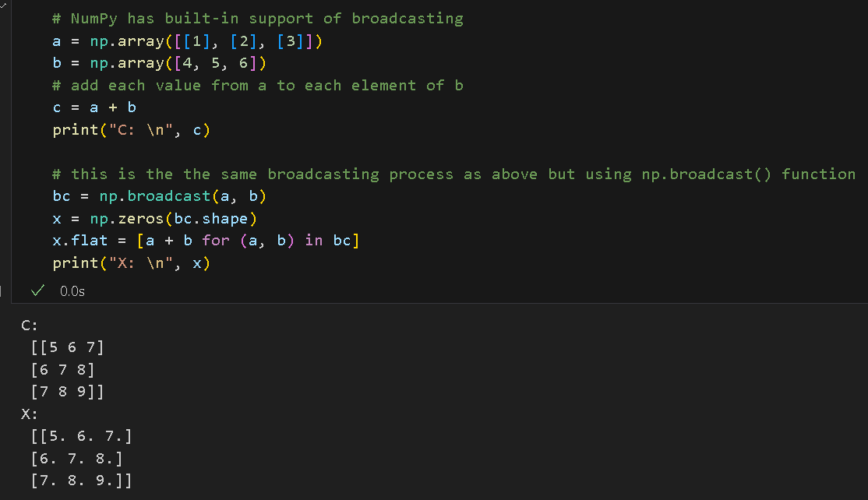

E. Mathematical Functions
- NumPy offers a wide range of mathematical functions like np.sum, np.mean, np.median, np.std, np.min, np.max, and trigonometric functions like np.sin, np.cos, etc.

1. Add a new code cell in your “arrays.ipynb” notebook and type the following code. Run the code cells by clicking on the run button on the upper left side of the cells.
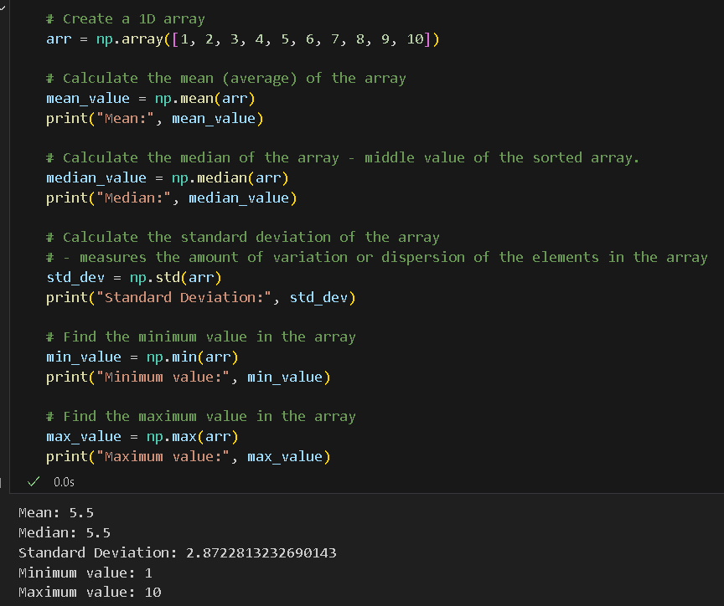

F. Random Number Generation
- The numpy.random module provides functions for generating random numbers, drawing samples from different distributions, and more. Examples include np.random.rand(), np.random.randn(), np.random.randint().

  - Add a new code cell in your “arrays.ipynb” notebook and type the following code. Run the code cells by clicking on the run button on the upper left side of the cells.

NOTE: THE RESULTS WILL NECESSARILY MATCH THE RESULTS FROM THE IMAGE BELOW.
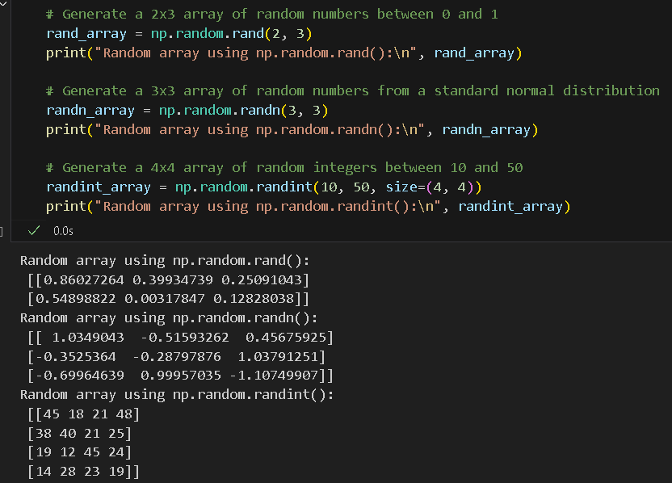

G. File I/O
- NumPy provides functions to save and load data in binary (.npy) and text formats:
  - np.save() and np.load() for binary files.
  - np.savetxt() and np.loadtxt() for text files.
    - Add a new code cell in your “arrays.ipynb” notebook and type the following code. Run the code cell.
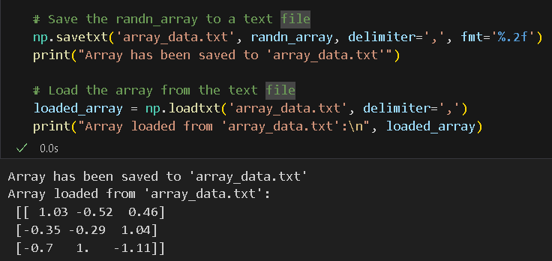
This will create a .txt file in your working folder. Please include it in your submission.
Push your work to GitHub
Follow the instructions on the CityU STC TA Center Github.io Submit your work page

You may also follow the instructions below:
1. Open the cmd terminal for Windows users,
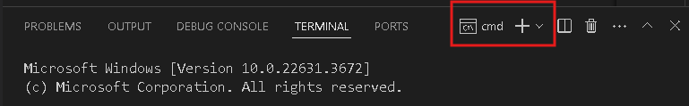

2. After selecting the + button, make sure the terminal is cmd if you have not closed the Python terminal.

If the terminal is not cmd, then you need to add it by opening the drop-down box, choose the Select Default Profile.
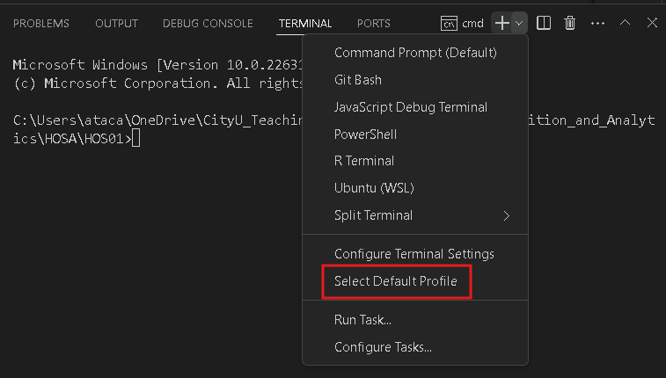

Look for and then select Command Prompt
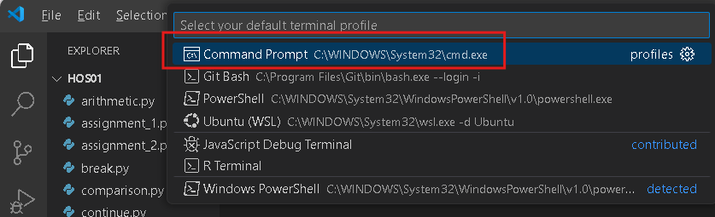

Click the + button. The command prompt will open.

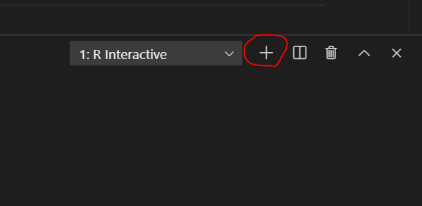

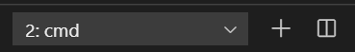

3. Make sure you are in the correct directory/repository: Desktop/DS522/hos03a-courseName-yourUserName

Run the following commands to push your work to the GitHub repository:
Open the terminal from the VSCode by hitting the control + ~ key and type the following command:
>>> git add .
>>> git commit -m “Submission for HOS03A-Numpy Basics”
>>> git push

*** Please answer HOS03B in Brightspace. ***

